**EXP NO: 03 DATE:**

# DEVELOP A LEXICAL ANALYSER TO RECOGNIZE A FEW PATTERNS IN C. (EX.IDENTIFIERS, CONSTANTS, COMMENTS, AND OPERATORS, ETC.) USING LEX TOOL.

**AIM:**

To develop a Lexical Analyzer using the LEX tool that recognizes different tokens in a given C program snippet, including Identifier, Constants, Comments, Operators, Keywords, Special Symbols.

**ALGORITHM:**

# Start

* Define token patterns in **LEX** for:
  + **Keywords** (e.g., int, float, if, else)
  + **Identifiers** (variable/function names)
  + **Constants** (integer and floating-point numbers)
  + **Operators** (+, -, =, ==, !=, *, /)
  + **Comments** (// single-line, /* multi-line */)
  + **Special Symbols** ({, }, (, ), ;, ,)
* Read input source code.
* Match the code tokens using LEX rules.
* Print each recognized token with its type.

# End PROGRAM:

%{

#include <stdio.h> #include <stdlib.h> #include <string.h> #include <stddef.h>

%}

%%

"int"|"float"|"if"|"else" { printf("KEYWORD: %s\n", yytext); }

[a-zA-Z_][a-zA-Z0-9_]* { printf("IDENTIFIER: %s\n", yytext); } [0-9]+ { printf("INTEGER CONSTANT: %s\n", yytext); }

[0-9]*\.[0-9]+ { printf("FLOAT CONSTANT: %s\n", yytext); }

\/\/.* { printf("SINGLE-LINE COMMENT\n"); }

\/\*([^*]|\*+[^/*])*\*\/ { printf("MULTI-LINE COMMENT\n"); }

\+|\-|\*|\/|\%|=|==|!= { printf("OPERATOR: %s\n", yytext); } [\{\}\(\)\;\,] { printf("SPECIAL SYMBOL: %s\n", yytext); } [ \t\n] { }

%%

int yywrap() { return 1;

}

int main() { yylex(); return 0;

}

# OUTPUT:

lex lexer.l

cc lex.yy.c -o lexer

./a.out Sample Input int main() { int a = 10; float b = 20.5;

/* This is a multi-line comment */ if (a > b) {

a = a + b;

}

return 0;

}

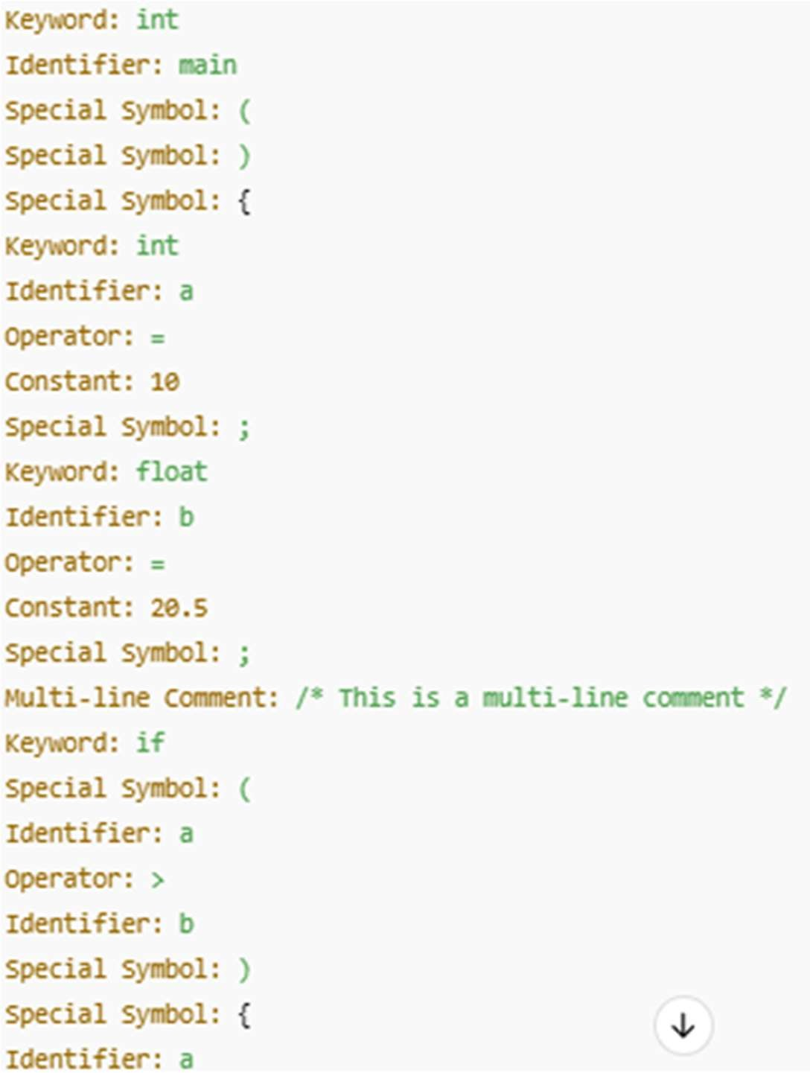

|  |  |
| --- | --- |
| **Implementation** |  |
| **Output/Signature** |  |

# RESULT:

Thus the above program reads a C code snippet, tokenizes it using LEX rules, recognizes and categorizes keywords, identifiers, constants, operators, comments, and special symbols, and then displays each token along with its type.